Searching a Single Multi-list Values Based on Parent using Lucene

I recently worked on an auto complete feature - which will check the typed characters in multiple fields inside an item. This includes multiple “Multi-List fields” as well.



When the fields are indexed using Lucene -> the Multi-List fields are stored as IDs separated by ‘|’ symbol. As it stores IDs of selected items, its not possible to check directly for the typed characters in a multi-list field.**The second challenge was to filter results from a single multilist field in item and filter it based on its Parent Item.** There is a work around for this and its simple ! Lets see how it can be done.

1. Lets check the multilist field and Categories:

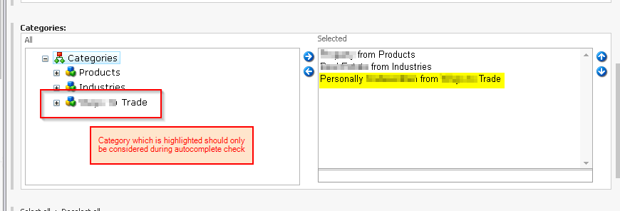

There are items on right with Multiple Items assigned from different categories from left. We have to filter out only the “Trade” items.

1. Using Computed Field to index a field value based on its Parent:

**Lets convert the selected value from ID to a string values combined using a “|” symbol and check if the parent is Trade**

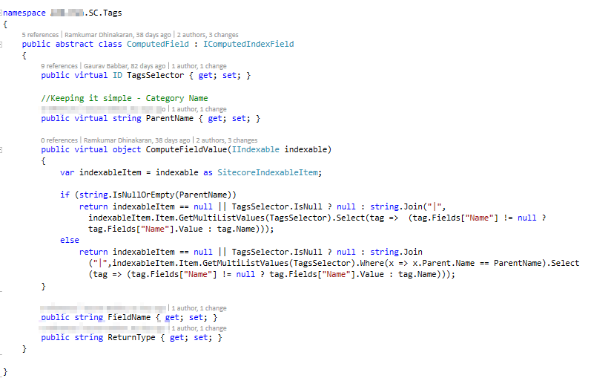

**Trade Custom Tags inheriting ComputedField: It will filter and store the Field Value “Only if Parent Name Matches”**

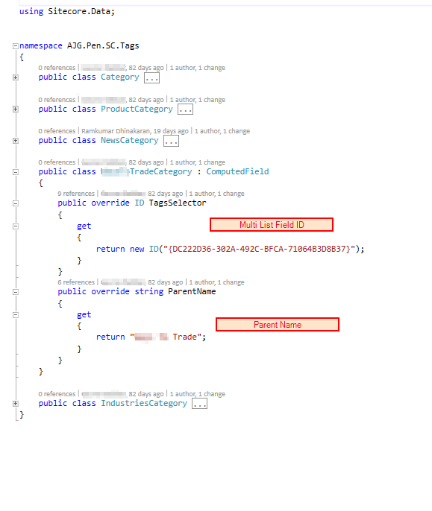

Make sure to include the Computed Fields in Index configurations.

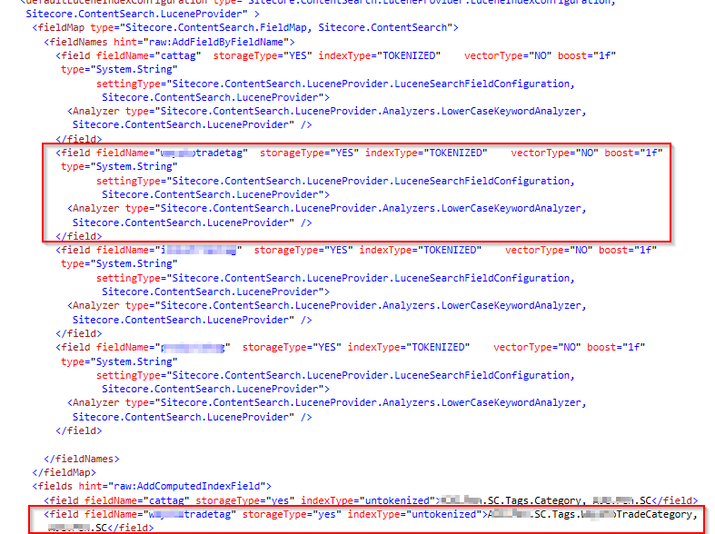

*Note: You can use Luke to check how the Computed field index is stored*

1. Now its time to write some search conditions to filter out the data !

The filtered value can be queried easily to check if typed letters match with the Category.

